Rockbuster Stealth Data Analysis

Data Dictionary

By David Boyd



**Table of Contents**

1. Entity Relationship Diagram (ERD)………………………………………………………………………………………………………………3
2. Fact Tables………………………………………………………………………………………………………………………………………………….4
   1. Payment Table……………………………………………………………………………………………………………………………..4
   2. Rental Table…………………………………………………………………………………………………….……………………………4
3. Dimension Tables……………………………………………………………………………………………………………………………………….5
   1. Staff Table…………………………………………………………………………………………………….………………………………5
   2. Customer Table……………………………………………………………………………………………….……………………………6
   3. Address Table……………………………………………………………………………………………….………………………………7
   4. Store Table …………………………………………………………………………………………………………………………………..8
   5. Country Table……………………………………………………………………………………………….………………………………9
   6. City Table…………………………………………………………………………………………………….……………………………….9
   7. Film Table………………………………………………………………………………………………….…………………………….…10
   8. Film Actor Table ………………………………………………………………………………………………………………………..11
   9. Actor Table..……………………………………………………………………………………………….………………………………11
   10. Language Table ……………………………………………………………………………………….…………………………………12
   11. Film Category Table ….……………………………………………………………………………………………………………….12
   12. Category Table……………………………………………………………………………………………………………………………13
   13. Inventory Table ………………………………………………………………………………………………………………………….13
4. ERD

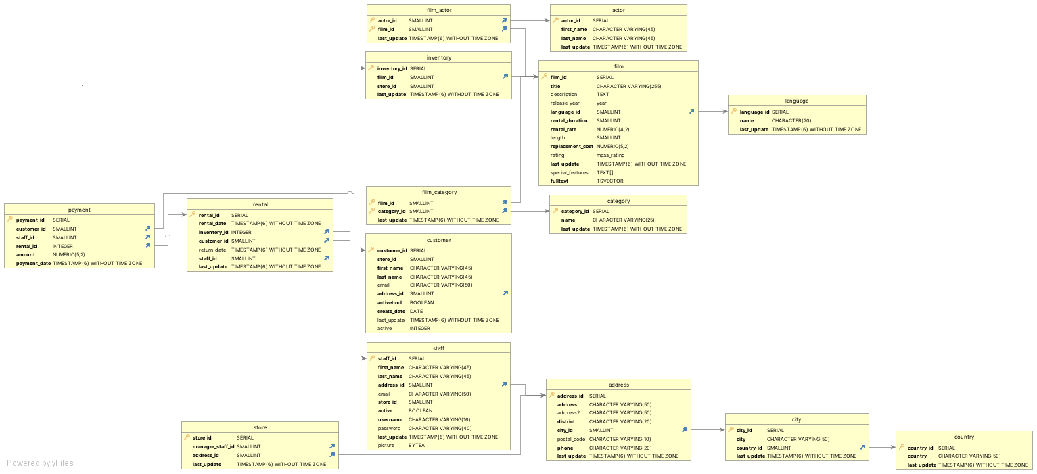

**2. Fact Tables**

2.1 Payment Table

|  |  |  |  |
| --- | --- | --- | --- |
| Payment | | | |
| Key | **Column** | **Data Type** | **Description** |
| Primary Key | Payment_id | Serial | Unique identifier for payment |
| Foreign Key | Customer_id | Small int | Unique identifier for customer |
| Foreign Key | Staff_id | Small int | Unique identifier for staff |
| Foreign Key | Rental_id | Integar | Unique identifier for rental |
|  | Amount | Number(5,2) | Cost in numerical value |
|  | Payment_date | Timestamp(6) without time zone | Time and date of payment without time zone |

Payment Table Links To:

|  |  |
| --- | --- |
| Table | Link |
| Customer | Payment.customer_id=Customer.customer_id |
| Staff | Payment.staff_id=Staff.staff_id |
| Rental | Payment.rental_id=Rental.rental_id |

2.2 Rental Table

|  |  |  |  |
| --- | --- | --- | --- |
| Rental | | | |
| Key | **Column** | **Data Type** | **Description** |
| Primary Key | Rental_id | Serial | Unique identifier for rental |
|  | Rental_date | Timestamp(6) without time zone | Time and date of rental without time zone |
| Foreign Key | Inventory_id | Integer | Unique identifier for inventory |
| Foreign Key | Customer_id | Small int | Unique identifier for customer |
|  | Return_date | Timestamp(6) without time zone | Time and date of return without time zone |
| Foreign Key | Staff_id | Small int | Unique identifier for staff |
|  | Last_update | Timestamp(6) without time zone | Time and update of last update without time zone |

|  |  |
| --- | --- |
| Table | Link |
| Inventory | Rental.inventory_id=Inventory.Inventory_id |
| Customer | Rental.customer_id=Customer.customer_id |
| Staff | Rental.staff_id=Rental.rental_id |

**3. Dimension Tables**

3.1 Staff Table

|  |  |  |  |
| --- | --- | --- | --- |
| Staff | | | |
| Key | **Column** | **Data Type** | **Description** |
| Primary Key | Staff_id | Serial | Unique identifier of staff member |
|  | First_name | Character varying (45) | First name of staff member |
|  | Last_name | Character varying (45) | Last name of staff member |
| Foreign Key | Address_id | Small int | Unique identifier of address |
|  | Email | Character varying (50) | Staff member email address |
|  | Store_id | Small int | Unique identifier of store |
|  | Active | Boolean | Status of whether staff is currently employed |
|  | Username | Character varying (16) | Staff member’s username |
|  | Password | Character varying (40) | Staff member’s password |
|  | Last_update | Timestamp(6) without timezone | Last update of staff member profile |
|  | Picture | Bytea | Picture of staff member |

Staff Table Links to

|  |  |
| --- | --- |
| Table | Link |
| Address | Staff.address_id=address.address_id |

Staff Table Links from

|  |  |
| --- | --- |
| Table | Link |
| Store | Store.manager_staff_id=staff.staff_id |
| Rental | Rental.staff_id=staff.staff_id |
| Payment | Payment.staff_id=staff.staff_id |

3.2 Customer Table

|  |  |  |  |
| --- | --- | --- | --- |
| Customer | | | |
| Key | **Column** | **Data Type** | **Description** |
| Primary Key | Customer_id | Serial | Unique identifier of customer |
| Foreign Key | Store_id | Small int | Unique identifier of store |
|  | First_name | Character varying (45) | First name of customer |
|  | Last_name | Character varying (45) | Last name of customer |
|  | Email | Character varying (50) | Customer email address |
| Foreign Key | Address_id | Small int | Unique identifier of address |
|  | Activebool | Boolean | Status of whether customer is active or not |
|  | Create_date | Date | Date of customer profile creation |
|  | Last_update | Timestamp(6) without time zone | Last update of customer profile without time zone |
|  | Active | Integer | Active status represented by 1 or 0 |

Customer Table Links to

|  |  |
| --- | --- |
| Table | Link |
| Address | Customer.address_id=address.address_id |

Customer Table Links from

|  |  |
| --- | --- |
| Table | Link |
| Rental | Rental.customer_id=customer.customer_id |
| Payment | Payment.customer_id=customer.customer_id |

3.3 Address Table

|  |  |  |  |
| --- | --- | --- | --- |
| Address | | | |
| Key | **Column** | **Data Type** | **Description** |
| Primary Key | Address_id | Serial | Unique identifier of address |
|  | Address | Character varying (50) | First line of address |
|  | Address2 | Character varying (50) | Second line of address |
|  | District | Character varying (20) | Region of address |
| Foreign Key | City_id | Small int | Unique identifier of city |
|  | Postal_code | Character varying (10) | Postal code for address |
|  | Phone | Character varying (20) | Phone number for address |
|  | Last_update | Timestamp(6) without time zone | Last update of address without time zone |

Address Table Links to

|  |  |
| --- | --- |
| Table | Link |
| City | Address.city_id=city.city_id |

Address Table Links from

|  |  |
| --- | --- |
| Table | Link |
| Staff | Staff.address_id=address.address_id |
| Store | Store.address_id=address.address_id |
| Customer | Customer.address_id=address.address_id |

3.4 Store Table

|  |  |  |  |
| --- | --- | --- | --- |
| Store | | | |
| Key | **Column** | **Data Type** | **Description** |
| Primary Key | Store_id | Serial | Unique identifier of store |
| Foreign Key | Manager_staff_id | Small int | Unique identifier of staff manager |
| Foreign Key | Address_id | Small int | Unique identifier of address |
|  | Last_update | Timestamp(6) without time zone | Last update of store profile without time zone |

Store Table Links to

|  |  |
| --- | --- |
| Table | Link |
| Staff | Store.manager_staff_id=staff.staff_id |
| Address | Store.address_id=address.address_id |

3.5 Country Table

|  |  |  |  |
| --- | --- | --- | --- |
| Country | | | |
| Key | **Column** | **Data Type** | **Description** |
| Primary Key | Country_id | Serial | Unique identifier of country |
|  | Country | Character varying (50) | Name of country |
|  | Last_update | Timestamp(6) without time zone | Last update of store profile without time zone |

Country Table Links from

|  |  |
| --- | --- |
| Table | Link |
| City | City.country_id=country.country_id |

3.6 City Table

|  |  |  |  |
| --- | --- | --- | --- |
| City | | | |
| Key | **Column** | **Data Type** | **Description** |
| Primary Key | City_id | Serial | Unique identifier of city |
|  | City | Character varying (50) | Name of city |
| Foreign Key | Country_id | Small int | Unique identifier of city |
|  | Last_update | Timestamp(6) without time zone | Last update of city without time zone |

City Table Links to

|  |  |
| --- | --- |
| Table | Link |
| Country | City.country_id=country.country_id |

City Table Links from

|  |  |
| --- | --- |
| Table | Link |
| Address | Address.city_id=city.city_id |

3.7 Film Table

|  |  |  |  |
| --- | --- | --- | --- |
| Film | | | |
| Key | **Column** | **Data Type** | **Description** |
| Primary Key | film_id | Serial | Unique identifier of film |
|  | Title | Character varying (225) | Full title of film |
|  | Description | Text | Description of film |
|  | Release_year | Year | Release year of film |
| Foreign Key | Language_id | Small int | Unique identifier of language |
|  | Rental_duration | Small int | Duration of rental |
|  | Rental_rate | Numeric(4,2) | Cost of rental |
|  | Length | Small int | Length of film |
|  | Replacement_cost | Numeric)5,2) | Cost to replace film |
|  | Rating | Mpaa_rating | Rating of film |
|  | Last_update | Timestamp(6) without time zone | Last update of film profile without time zone |
|  | Special_features | Text[] | Special features of film |
|  | Fulltext | Tsvector | Full text index; information about significant words and their location |

Film Table Links to

|  |  |
| --- | --- |
| Table | Link |
| Language | Film.language_id=languge.language_id |

Film Table Links from

|  |  |
| --- | --- |
| Table | Link |
| Film Actor | Film_actor.film_id=film.film_id |
| Inventory | Inventory.film_id=film.film_id |
| Film Category | Film_category.film_id=film.film_id |

3.8 Film Actor Table

Film Actor Table Links to

|  |  |
| --- | --- |
| Table | Link |
| Film | Film_actor.film_id=film.film_id |
| Actor | Film_actor.actor_id=actor.actor_id |

|  |  |  |  |
| --- | --- | --- | --- |
| Film_actor | | | |
| Key | **Column** | **Data Type** | **Description** |
| Primary Key, Foreign Key | actor_id | Small int | Unique identifier of actor |
| Primary Key, Foreign Key | Film_id | Small int | Unique identifier of film |
|  | Last_update | Timestamp(6) without time zone | Last update of film actor without time zone |

3.9 Actor Table

|  |  |  |  |
| --- | --- | --- | --- |
| actor | | | |
| Key | **Column** | **Data Type** | **Description** |
| Primary Key | actor_id | Serial | Unique identifier of actor |
|  | First_name | Character varying (45) | First name of actor |
|  | Last_name | Character varying (45) | Last name of actor |
|  | Last_update | Timestamp(6) without time zone | Last update of actor profile without time zone |

Actor Table Links From

|  |  |
| --- | --- |
| Table | Link |
| Film Actor | Film_actor.actor_id=actor.actor_id |

3.10 Language Table

|  |  |  |  |
| --- | --- | --- | --- |
| Language | | | |
| Key | **Column** | **Data Type** | **Description** |
| Primary Key | Language_id | Serial | Unique identifier of language |
|  | Name | Character (20) | Name of language |
|  | Last_update | Timestamp(6) without time zone | Last update of language without time zone |

Language Table Links from

|  |  |
| --- | --- |
| Table | Link |
| Film | Film.language_id=language.language_id |

3.11 Film Category Table

|  |  |  |  |
| --- | --- | --- | --- |
| Film_category | | | |
| Key | **Column** | **Data Type** | **Description** |
| Primary Key, Foreign Key | Film_id | Small int | Unique identifier of film |
| Primary Key, Foreign Key | Category_id | Small int | Unique identifier of category |
|  | Last_update | Timestamp(6) without time zone | Last update of film without time zone |

Film Category Table Links to

|  |  |
| --- | --- |
| Table | Link |
| Film | Film_category.film_id=film.film_id |
| Category | Film_category.category_id=category.category_id |

3.12 Category Table

|  |  |  |
| --- | --- | --- |
| Category | | |
| Column | **Data Type** | **Description** |
| Category_id | Serial | Unique identifier of category |
| Name | Character varying (25) | Name of category |
| Last_update | Timestamp(6) without time zone | Last update of category without time zone |

Category Table Links from

|  |  |
| --- | --- |
| Table | Link |
| Film Category | Film_category.category_id=category.category_id |

3.13 Inventory Table

|  |  |  |  |
| --- | --- | --- | --- |
| Inventory | | | |
| Key | **Column** | **Data Type** | **Description** |
| Primary Key | Inventory_id | Serial | Unique identifier of inventory |
| Foreign Key | Film_id | Small int | Unique identifier of film |
| Foreign Key | Store_id | Small int | Unique identifier of store |
|  | Last_update | Timestamp(6) without time zone | Last update of inventory without time zone |

Inventory Table Links to

|  |  |
| --- | --- |
| Table | Link |
| Film | Inventory.film_id=film.film_id |

Inventory Table Links from

|  |  |
| --- | --- |
| Table | Link |
| Rental | Rental.inventory_id=inventory.inventory_id |